Phase 3 Draft

### 3.1 Research for Components, Materials, Companies, and Suppliers (201777135)

After researching online, we have found some information about how to achieve our project. We are going to use EMG to control the UAV and use communication device to connect them. Therefore, we list some subsystems below to show some details, including components, materials, companies, labour and suppliers.

#### 3.1.1 EMG Devices and companies

EMG sensors are used to capture the electrical signals generated by muscle activity. They typically appear in the form of surface sensors, installed on the skin surface to non-invasively monitor the electrical activity of muscles. These sensors are crucial for the real-time capture and transmission of electromyographic signals to the processing unit. After that, the unit will process these electromyographic signals. But to keep the high quality of the signals provided by the recording system, we need to keep the high fidelity of the signals obtained by the sensor determines The rest of the system can only deteriorate the quality of the signals. [1].

Besides, we also searched information about some EMG devices companies. Noraxon USA [2] stands out as a pivotal player in the field of motion science technology and biomechanical analysis. The company has established a strong reputation for manufacturing high-quality EMG equipment, which is widely utilized in both research and clinical diagnostics. Noraxon offers an extensive range of EMG systems, including both wireless and wired configurations, complemented by a diverse array of sensors and software specifically designed for motion analysis. This technology enables precise monitoring and analysis of muscle activity, which is crucial for our project's aim to control UAVs using muscle-generated electrical signals. Another significant contributor is Delsys [3], known for its focus on high-precision electrophysiological measurement devices. Delsys’s EMG systems are renowned for their accuracy and reliability, making them a popular choice across the globe for studies in biomechanics and ergonomics. The company's portfolio includes a variety of EMG sensors [4], such as surface EMG systems and innovative wireless solutions that offer flexibility and ease of use in data collection without the encumbrance of wires. BIOPAC Systems [5] also plays a critical role in our research by providing a wide range of physiological monitoring devices, including advanced EMG systems. These systems are designed to cater to both basic and complex research needs in biomechanics and physiology, thus supporting a broad spectrum of scientific inquiries and educational purposes.

#### 3.1.2 Microcontroller

As for the function of the signal processing unit, it is to receive the raw electrical signals from the EMG sensors, amplify and filter them to enhance the quality and usability of the signals. This includes removing noise and unnecessary frequency components, ensuring that the signals sent to the microcontroller are clear and reliable.[6] In our project, microcontrollers play an important role and we have found some companies which are competitive (such as Arduino [7] and Raspberry Pi). Their main function is to receive processed electromyography (EMG) signals and convert these signals into control instructions. These instructions are then utilized to command the unmanned aerial vehicle (UAV), controlling various actions such as takeoff, landing, and directional movements. The signal processors are tasked with refining these signals through amplification [8] and filtering, ensuring that only clear and reliable data is forwarded to the microcontrollers. Microcontrollers such as Arduino and Raspberry Pi are employed to interpret these processed signals and convert them into actionable commands for UAV operation. These microcontrollers play a pivotal role in managing communications with wireless transmission modules, which are responsible for sending these commands to the UAVs.

#### 3.1.3 Wireless communication

Regarding wireless communication, suppliers like Nordic Semiconductor and Espressif Systems are good choices for us. As they provide reliable wireless communication solutions. The wireless modules these companies supply are responsible for transmitting the control instructions generated by the microcontrollers to the UAVs wirelessly. This functionality enables operators to remotely control UAVs using EMG signals, eliminating the need for physical connections. Depending on the required control distance and data transmission rate, the choice of technology may vary between Bluetooth and Wi-Fi.

#### 3.1.4 Unmanned aerial vehicle

Drones hold significant market potential and a promising future due to their versatility and wide range of applications. They are increasingly used in various industries, including agriculture for crop monitoring, real estate for aerial photography, and delivery services for transporting goods. The continuous advancements in drone technology, coupled with decreasing costs and regulatory support, further enhance their appeal and expand their market opportunities. In our project, we are going to use the drone in agriculture which is potential and more and more important in our life. Here



Figure1: Agricultural Drone Market size

**Company:** DJI Innovations [9]

**Introduction:** DJI is the largest consumer drone manufacturer in the world which is located in Shenzhen, China. The company is renowned for its technologically advanced drones used for photography, videography, commercial and industrial applications as well as agriculture.

**Products:** DJI T50, DJI T40, DJI T30, DJI T25, DJI T10, etc.

Here we can choose DJI T10 which is designed specifically for small-scale farming applications with spraying system. This model is suitable for beginners due to its user-friendly interface and simplified operations. Compared to larger models, the T10 offers a balance of efficiency and affordability, making it an attractive option for those new to agricultural drone technology.

**Price:**￡7800 [10]

**Company:** Parrot [11]

**Introduction:** Parrot is a French drone manufacturer which is also well-known for its consumer-grade and recreational drones. It also provides some models which are suitable for agriculture. Its drones are primarily focused on monitoring and data collection in agriculture rather than chemical spraying.

**Products:** Parrot Bluegrass Fields

This drone is specifically designed for agricultural monitoring, equipped with a spectral sensor to capture critical data about crop. It is ideal for crop analysis and help farmers optimize crop management.

**Price:**￡1099 [12]

**Company:** Intel [13]

**Introduction:** Intel is primarily known for its microprocessors and computing technology. It has also started the items about the drone industry and created numerous spectacular drone light shows, including the Super Bowl halftime shows and Olympic ceremonies. Besides, Intel collaborates with various drone manufacturers and software developers to integrate its technologies into a broader range of applications.

**Products:** Intel Falcon 8+

The Intel Falcon 8+ is one of Intel's most notable drone which is designed for professional users in different fields. It includes construction, surveying, and industrial inspections. This drone is known for its advanced stability and precision. But unfortunately, it is not especially designed for agriculture that we need to adjust the drone if we want to use it.

**Price:**$9269 [14]

#### 3.1.5 Power Management

Power supply is another critical aspect, with top suppliers such as Panasonic[15] and Samsung[16] providing the batteries needed to ensure a stable and sufficient power supply to all system components. The use of rechargeable lithium batteries is common due to their high energy density and durability, which is ideal for both portable and field applications.

### 3.2 Bill of Materials（201716692）

|  |  |  |  |  |
| --- | --- | --- | --- | --- |
| component Type | Manufacturer | Quantity | Price | Distributor |
| STM32 | STMicroelectronics | 1 | £12.16 | RS |
| instrumentation amplifier | texas instruments | 1 | £3.70 | Onecall |
| differential amplifier | texas instruments | 1 | £5.57 | Onecall |
| ESP32 | dfrobot | 1 | £7.01 | Onecall |
| welding tools | Ferstalo | 1 | £18.99 | Amazon |
| Unmanned aerial vehicle | DJI Innovations | 1 | ￡7800 | Dji website |
| WiFi shirld | sparkfun | 1 | 15.95 | Sparkfun website |
| Bluetooth module | Digilent, Inc. | 1 | £20.09 | Digikey |

### 3.3 Manufacturing and Time Plan (201715540)

#### 3.1.1 Manufacturing Plan

For the deployment of watering drones and EMG, we have outlined a plan to procure necessary materials and manage the production and testing processes at the respective factories, as illustrated in the figure below. The primary objective is to assemble the acquired components and subsequently conduct testing on the assembled EMG equipment and drones. This involves debugging, testing, and software flashing to ensure the proper functioning of the drone's spraying mechanism and irrigation system. Additionally, we will evaluate the irrigation monitoring system on the server to verify its accuracy and effectiveness.

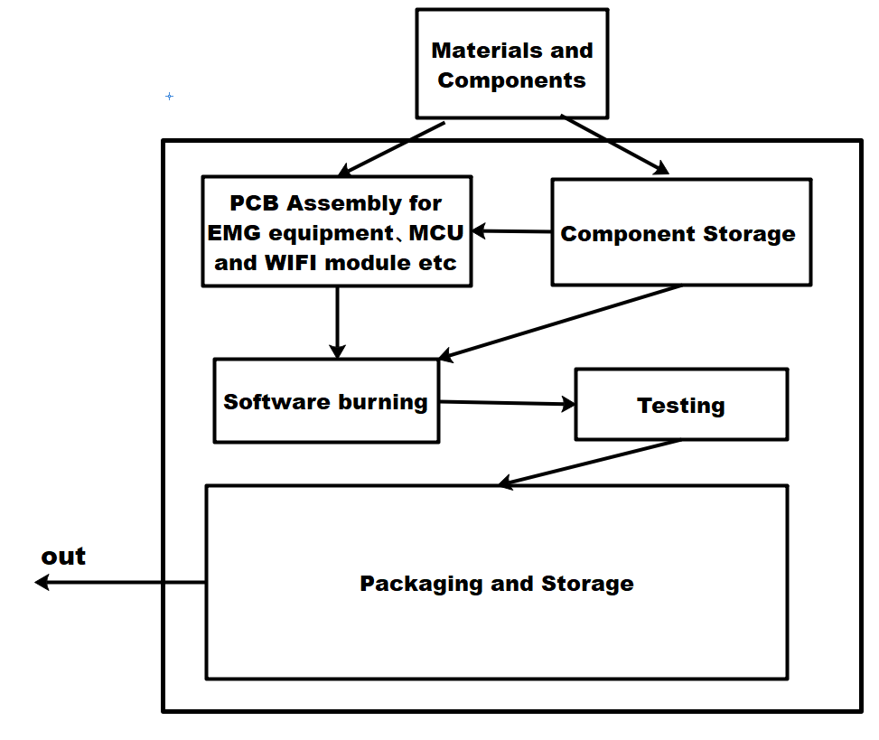

figure 2. A diagram to show a proposed factory floor plan for manufacturing the EMG-driven Quadcopter Agricultural Irrigation System.

After assembling the necessary equipment at the factory, our team will proceed to pack and ship it to relevant agricultural companies in third-world countries via sea or train. We will provide assistance with installation and configuration, including setting up WiFi connections, linking to servers, and conducting drone operation training. This will enable more disabled individuals to quickly adapt to these tasks.

For initial validation, we may opt to purchase finished products to confirm the validity of our concepts. For EMG finished products, the MyoWare 2.0 kit [17] can serve this purpose. Once we confirm the EMG signal's readability, we will proceed to verify whether our designed circuit diagram can be successfully manufactured. To accomplish this, we may engage Jialichuang Company [18] in China to design and validate the PCB board, as they offer free board design and verification services. As for the MCU selection, we intend to use STM32[19], and for the WiFi expansion module, the Qwiic WiFi Shield based around the DA16200 module[20] is preferred. Additionally, we may acquire a Bluetooth module concurrently to expedite development[21].

Upon successful verification, we may choose to purchase the microcontroller and components separately to minimize costs. Our primary objective is to reduce expenses to a minimum, enabling us to assist as many third-world countries as possible and lift numerous impoverished individuals out of poverty. Furthermore, besides its application in the planting industry, this system can be utilized for forest fire prevention and urban greening, facilitating the involvement of disabled individuals in multiple industries [22].

#### 3.1.2 Time Plan

In order to standardize the progress of project manufacturing, installation, and promotion, we completed the production of a Gantt chart, as shown in the following figure:

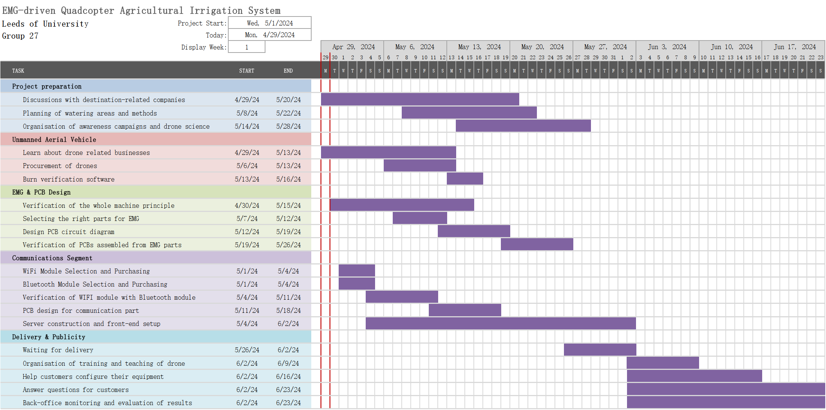

figure 3. The Gantt chart for all installation stages of the EMG-driven Quadcopter Agricultural Irrigation System.

[1] Yang Xu-Sheng, Li Fu-Xiang, Hu Fo, Zhang Wen-An. Human motion estimation based on EMG-inertial fusion: A gaussian filtering network approach. Acta Automatica Sinica, 2024, 50(5): 1−10 doi: 10.16383/j.aas.c230581

[2] Noraxon USA Website: <https://www.noraxon.com/>

[3] Delsys Website: <https://delsys.com/>

[4] EMG Sensor:

<https://onecall.farnell.com/seeed-studio/101020058/sensor-board-emg-detector-grove/dp/MK01062>

[5] BIOPAC Systems: <https://www.biopac.com/>

[6]Research Status and Trend Analysis of Landscape Perception Evaluation Based on Deep Learning[J]. Design, 2024, 09(02): 503-509. <https://doi.org/10.12677/design.2024.92238>

[7] Arduino: <https://onecall.farnell.com/dfrobot/dfr0216/dfrduino-uno-r3-8bit-avr-atmega/dp/4308178?st=dfr0216>

[8] <https://onecall.farnell.com/texas-instruments/ina117p/amp-instrumentation-200khz-pdip8/dp/SC18457>

[9]<https://ag.dji.com/t10)>

[10]<https://www.heliguy.com/products/dji-agras-t10-drone)>

[11]<https://www.parrot.com/uk)>

[12]<https://www.ebay.co.uk/itm/266426241440?_ul=GB)>

[13]https://www.intel.cn/content/www/cn/zh/products/sku/98471/intel-aero-ready-to-fly-drone/specifications.html

[14]<https://www.heliguy.com/products/dji-agras-t10-drone)>

[15][Electronics, Beauty & Appliances | Panasonic UK & Ireland](https://www.panasonic.com/uk/)

[16][Samsung UK | Mobile | Home Electronics | Home Appliances | TV](https://www.samsung.com/uk/)

[17][MyoWare 2.0 Muscle Sensor Development Kit - KIT-21269 - SparkFun Electronics](https://www.sparkfun.com/products/21269)

[18][立创商城_一站式电子元器件采购自营商城_嘉立创电子商城 (szlcsc.com)](https://www.szlcsc.com/)

[19][DEV-21438 SparkFun 电子 |开发板、套件、编程器 |得捷电子 --- DEV-21438 SparkFun Electronics | Development Boards, Kits, Programmers | DigiKey](https://www.digikey.co.uk/en/products/detail/sparkfun-electronics/DEV-21438/21703803?s=N4IgTCBcDaIMoBUCyBmMB1AQiAugXyA)

[20][SparkFun Qwiic WiFi Shield - DA16200 - WRL-18567 - SparkFun Electronics](https://www.sparkfun.com/products/18567)

[21][410-359 Digilent, Inc. | Development Boards, Kits, Programmers | DigiKey](https://www.digikey.co.uk/en/products/detail/digilent-inc/410-359/8605090)

[22][无人机在浇灌中的应用教程 - 百度文库 (baidu.com)](https://wenku.baidu.com/view/1699bfb432126edb6f1aff00bed5b9f3f80f7246.html?_wkts_=1714426096309&bdQuery=EMG%E6%93%8D%E6%8E%A7%E6%97%A0%E4%BA%BA%E6%9C%BA%E6%B5%87%E7%81%8C)